Assignment 5: Demonstration of Advanced Queries by Unix shell Implementation:

Query 1: List all usernames and passwords of users without names starting with “JJK”

(SELECT user_username, user_password

FROM users)

MINUS

(SELECT user_username, user_password

FROM users

WHERE user_name LIKE 'JJK%');

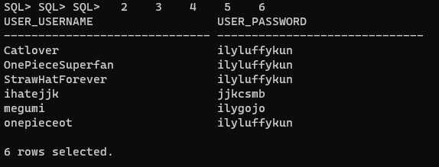

Query 2: List all item names and the average of their minimum bids, group by item names with averages less than 100

SELECT item_name, AVG(item_minBid)

FROM items

GROUP BY item_name

HAVING AVG(item_minBid) < 100;

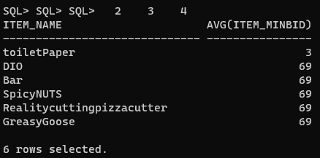

Query 3: Check the existence of items with a bid over 5 dollars

SELECT i.item_id, i.item_name

FROM items i

WHERE EXISTS(

SELECT b.bids_top

FROM bids b

WHERE b.bids_top > 5

AND i.item_id = b.item_id

);

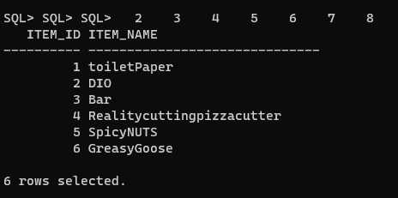

Query 4: List all item names and descriptions with an end date of '2023-10-11' and '2023-10-28'

SELECT item_name, item_description

FROM items

WHERE item_endDate = '2023-10-11'

UNION

(SELECT item_name, item_description

FROM items

WHERE item_endDate = '2023-10-28');

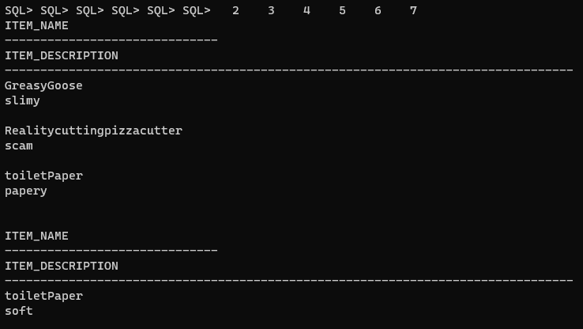

Query 5: The total number of bids a user has on an item

SELECT u.user_id, COUNT(b.item_id) AS total_bids

FROM pastbids b, users u

WHERE b.item_id=1

AND u.user_id = b.user_id

GROUP BY u.user_id;

